**Exercise 8: Implementing Basic AOP with Spring**

Scenario:

The library management application requires basic AOP functionality to separate cross-cutting concerns like logging and transaction management.

1. Introduction

In this exercise, we enhance the Library Management Application by introducing basic Aspect-Oriented Programming (AOP) with Spring. AOP helps in separating cross-cutting concerns like logging and transaction management from the business logic. We will implement logging using Spring AOP to demonstrate this functionality.

2. Step-by-Step Implementation

**Step 1: Defining the Aspect**

Update:  
We define an aspect in a new package, com.library.aspect. The aspect class is named LoggingAspect, and it is annotated with @Aspect and @Component to designate it as a Spring-managed aspect.

**Step 2: Creating Advice Methods**

Update:  
In the LoggingAspect class, we created two advice methods:

* logBeforeMethodExecution (): Executes before any method in the com.library.service package.
* logAfterMethodExecution (): Executes after any method in the com.library.service package.

These methods will log messages before and after method execution, allowing us to monitor the flow of the application

**@Before Advice**:

* logBeforeMethodExecution method will be executed before any method in the com.library.service package.
* It logs a message indicating the method that is about to be executed.

**@After Advice**:

* logAfterMethodExecution method will be executed after any method in the com.library.service package.
* It logs a message indicating the method that has just been executed.

**@Around Advice**:

* logExecutionTime method will measure and log the execution time of any method in the com.library.service package.
* This advice wraps the method execution, allowing it to measure the time before and after the method is executed.

**Step 3: Configuring the Aspect**

Update:  
We need to update the applicationContext.xml to register the aspect and enable AspectJ auto-proxying. This ensures that Spring will automatically create proxies for beans where aspects are applied.

**Step 4: Testing the Aspect**

Run the LibraryManagementApplication main class to test the AOP functionality. It runs without an error.

**Analysis:**

1. **Adding a Book**:
   * Before adding a book, logBeforeMethodExecution logs: "Before execution of: addBook".
   * After adding a book, logExecutionTime logs the execution time.
   * After adding a book, logAfterMethodExecution logs: "After execution of: addBook".
2. **Listing All Books**:
   * Before listing books, logBeforeMethodExecution logs: "Before execution of: listBooks".
   * After listing books, logExecutionTime logs the execution time.
   * After listing books, logAfterMethodExecution logs: "After execution of: listBooks".
3. **Searching for a Book by ISBN**:
   * Before searching for a book, logBeforeMethodExecution logs: "Before execution of: findBookByIsbn".
   * After searching for a book, logExecutionTime logs the execution time.
   * After searching for a book, logAfterMethodExecution logs: "After execution of: findBookByIsbn".

**FLOWCHART of the program :**

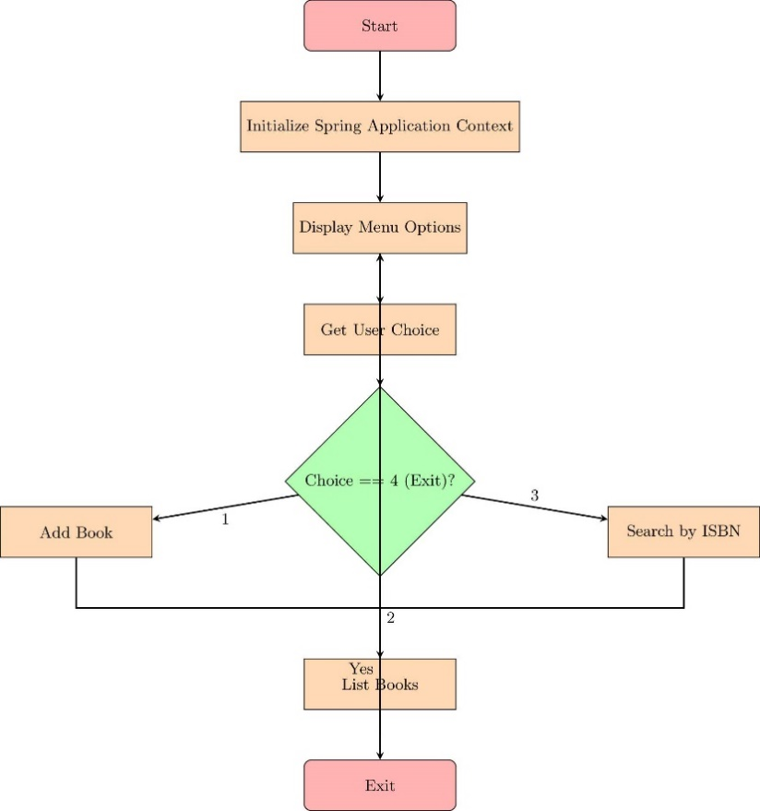

The flowchart depicts the flow of control in the LibraryManagementApplication class:

* Start: The application initializes the Spring Application Context.
* Menu Display: The user is presented with options to add a book, list all books, search by ISBN, or exit the application.
* User Choice: The user's choice is captured and processed:
  + Add Book: Prompts the user for book details and adds the book to the repository.
  + List Books: Retrieves and displays all books in the library.
  + Search Book: Searches for a book by its ISBN.
  + Exit: Terminates the application.
* Decision Points: The application checks if the user wants to exit. If not, the process loops back to display the menu again

**CLASS DIAGRAM :**

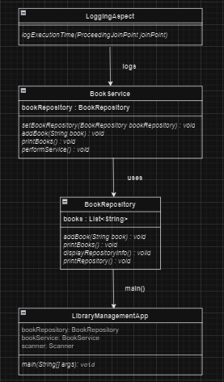

The class diagram illustrates the structure of the classes and their relationships:

* BookRepository: Manages a collection of Book objects and provides methods to add, retrieve, and search books.
* BookService: Provides services related to books, such as adding and listing books. It uses BookRepository for these operations.
* LoggingAspect: An aspect that logs method executions in the BookService class. It is applied before and after method calls to capture execution details.